5DV133

Objektorienterad Programmeringsmetodik:
Obligatorisk inlämningsuppgift 2 – Robot 2.0

Kursansvarig: Johan Eliasson (johane), johane@cs.umu.se

Övriga lärare: Anna Jonssson (aj),

Handledare: Lennart Steinvall (svartvit), Arvid Bergman Thörn (dv20arn), Oscar Kamf (oi17okf), Arvid Sundbom (mai21asm).

Student: Ahmad Kalash (id18akh),

Datum: 24/08/22

Table of Contents
Table of contents 2
Problem Description 3
Introduction 4
System description and UML Diagram 5
Tests & Reflections 6

Introduction

The following is an introduction to the second compulsory assignment in the course Object oriented programming methodology at Umeå University. The before mentioned assignment builds upon the previously handed assignment, whereas the first asked of the students to write a class named RandomRobot which had to keep track of a maze it is situated in, their previous position and their current position to find their way through the maze. The students also had to write their own maze class which compiled a maze object out of a raw .txt file containing the characters: “*” to symbolise walls, “S” to symbolise the Start position and “G” to symbolise the end Goal. Lastly the student had to write their own test program that had to made use of the command prompt on their own local development machine to return the results of their own programming. In order to verify whether or not their RandomRobot succeeded with their intended goal.
Following this assignment the student had to expand their project and add two more specific robot classes called MemoryRobot and RightHandRuleRobot respectively. Whereas the first had to remember the each position in the maze it has already traversed to and therefore try to evade them to the best of its ability in order to find the path forward. While the second had to use the class right hand rule and hug the right wall and traverse alongside it in order to find their way to the goal.
The student also had to create a mother class called Robot that would contain all the public common attributes and methods that all of the Robots shared. On top of that the students were given a specific test program that would allow them to observe visually each of the Robots’ behaviour in a given maze.

Problem Description

The challenge with this assignment was to first extend the RandomRobot to the mother Robot class and make sure that the inheritance works fine without breaking the student’s previous work. Thereafter follows the creation of two different algorithms for each of the two new Robot children classes that would fulfil their expected behaviour.
All said work had to of course work in the previous project environment without changing how the maze is read, nor how the positioning logic works either. Although if the student has fulfilled the previous assignment they have one testing program that requires minor changes in order to test if their working solutions actually fulfil their higher level goals.
Lastly they can make use of the “MazeSimulation.java” test program to double check that each of their respective new Robot works as intended.

System description and UML Diagram

The system in place is quite simple as it has close resemblance to the system in place for the previous assignment. This can be seen by examining the relationship between the new Robot mother class and the maze and the position class, which are the same the RandomRobot had during the previous system.
The current changes are of course the creation of the three children classes each containing specific attributes and methods unique to their own respective algorithm. Starting from the left we have the MemoryRobot which contains their unique attributes. It has the private protected Position Hashset ALREADYSEEN that is used to keep track of all the positions previously visited by the Robot. And it has the private protected Position stack MEMORYLOG that aids the previously named Hashset with their purpose. On top of that we have of course the public constructor and move functions which need to be public, as otherwise the Robot would be inaccessible to the tests. Lastly we have two supporting functions that are needed by this Robot’s specific algorithm in order to move around the labyrinth.
Now speaking of the algorithm here’s a clear description of how the Robot moves through the labyrinth:
- It firsts adds the current position to the ALREADYSEEN HashSet in order to keep track that this position has now been visited,
- Thereafter if it isn’t on the Goal position, it checks it’s surrounding by checking if each position north, south, west and east has already been visited and if it’s possible to move to,
- If there is a position that has not been visited and is available it will move there and add the previous position to the MEMORYLOG,
- If the robot finds a dead end before it finds the goal, it uses the MEMORYLOG to backtrack by popping each position on the Stack until it there is either a new path or it is back at position 0, thereafter it uses the different path forward until it reaches the goal.

Thereafter follows the RandomRobot which inherits all its attributes from the mother Robot class, given that it has been used as example for the mother class. But its’ move function follows its’ own respective algorithm as the one in the mother class is just a pretty placeholder. What the RandomRobot does when it moves is the following instead:
- It first and foremost checks for which possible routes are available and adds them to an ArrayList, thereafter it raffles out a position and sets their old position as their previous position.
- If there isn’t any possible routes available it just reverts to their previous position and tries again until it finds its’ way to the goal.
Lastly comes the RightHandRuleRobot, which is the complicated and elitist sibling out of the three. First and foremost it contains a public enum containing all possible 4 directions in a two dimensional labyrinth. This enum is used to define the concept of direction in the labyrinth. The Robot also sets their current direction at the start as North by using a protected attribute. The Robot’s move function works as follows:
- It first finds out of the Robot’s current front position and right position based on their current direction, aka 90 degrees counter clockwise.
- Thereafter it checks if the right position is movable to and if so it moves there and changes their direction accordingly,
- If not it checks if the front position is available and moves there and keeps their current direction,
- Otherwise it changes it’s direction 90 degrees clockwise and tries again,
- The robot simply repeats the above steps until it reaches their goal.
The Robots other methods are:
- The public rightHandDownDirection that sets the Robot’s direction 90 degrees counter clockwise and is used only if the Robot moves to the right.
- The public rightHandUpDirection that sets the Robot’s direction 90 degrees clockwise if the robot finds nowhere to go.
- It public has the getAdjacentPositionTowards method that is used to find the adjacent position compared to the Robots direction,
- It has the private void setDirection method that sets the robots current direction to a new updated value.
- The public getDirection method that returns the current Robot’s direction,
- And it’s own private setPosition that updates the Robot’s position which has remained in the class as an artefact of development. The author of the code and report is well aware that this method could be replaced by one in the position class or even an = sign, but the deadline is imminent and the desperation has rendered the author to a fearful programmer who does not dare to change working code for simplicity´s sake.

Lastly we have also in the UML diagram the unit test used to check of each specific Robot implementation. The addition to the UML is of course noted to not be necessary technically, but given it’s relevance in the report it felt necessary to include nonetheless. Although it is to be noticed that the current unit test only has strict correlation to the Position and Maze classes, as it has to be hard coded and specified specifically in the unit test code itself which robot is to be tested. This lack of strict correlation to either of the 3 children classes or the mother classes is reflected in the UML as such.

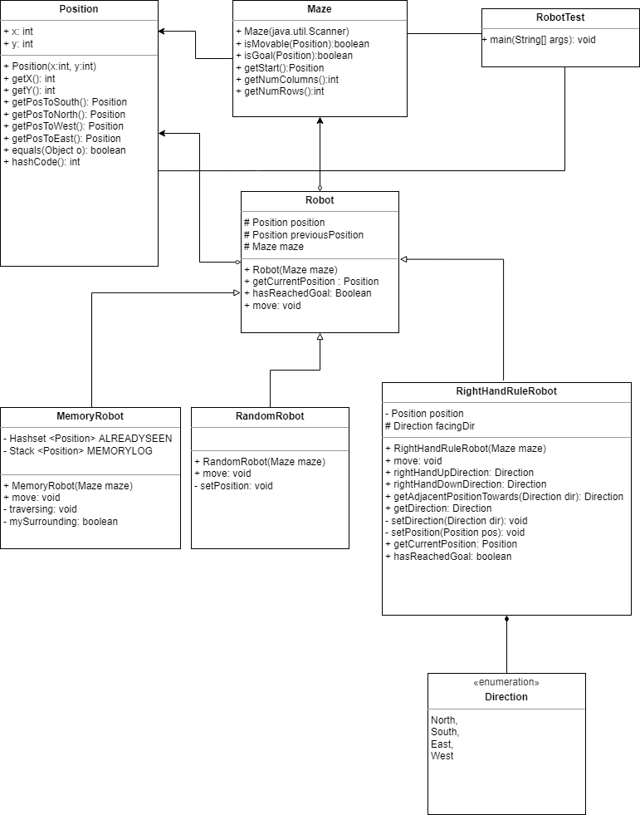

Tests & Reflections

As mentioned previously the unit test from the previous assignment has been used even in the current one to test the development of each of the three children respectively. Having a unit test already available has been noticed to be a very resourceful thing and the student writing this is very thankful for how the assignments were designed given that they themselves did not need to write one on their own.
The major test, aka “MazeSimulation.java” has also lead me to feel a strong sense of gratitude as my first iteration of the RightHandRuleRobot actually followed the left wall and not the right one and I would not have caught this mistake without having access to the graphical holistic point of view the test gave me.

The current project with the MazeSimulation.Java test can be compiled using the two following methods:
- For Linux / MacOS:
  - $ find -name "*.java" > sources.txt
  - $ javac @sources.txt
- For Windows:
  - dir /s /B *.java > sources.txt
  - javac @sources.txt

Both methods compile in Git bash / Command Prompt from my Windows machine without problems as seen by the following screenshots:
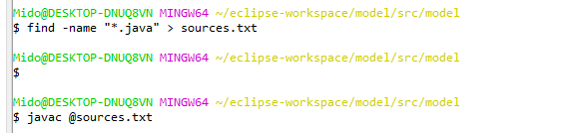
Otherwise I recommend importing to Eclipse or IntellJ and compile from there.
The final files can be found here: https://git.cs.umu.se/id18akh/5DV133_OU2_FINAL
My working Repo can be found here: https://git.cs.umu.se/id18akh/5dv133_ou2
I’ve divided them in order to keep clarity at a maximum level.

